

**SCHOOL MANAGEMENT SYSTEM**

**SUBMITTED BY**

**AKASH KUMAR NADIPALLI**

**12007137**

**SUBMITTED TO**

**Richa Sharma: 27957**





**INTRODUCTION:**

This project deals with the management criteria of the school. School is a place where the job is to admit the students, keep their records, take the examination, and give mark sheets and fulfilling their requirements. They are required to store the valuable data/ information’s for a longer period with easy accessing and manipulation of the same.

This project enables the School Staff in various school departments to handle the records efficiently, in comparatively lesser time with greater accuracy and hence improving the efficiency & reliability of staff. The project deals with various aspects of school functions viz. administration of the school management, registration of the incoming students, their admission in the school.

**Objective of the Project:**

The main objectives behind developing this project are as follows:

* To utilize resource of the institution in an efficient manner by increasing their productivity through automation.
* The system generates several types of reports that can be then used for various purposes.

Likewise, there are several objectives behind developing the “SCHOOL MANAGEMENT SYSTEM” and it reduces a lot of burden from the staff by simplifying the tasks etc.

The system generates a predetermined output on having the related input based on output for the required inputs are thought. No system can produce output without having the require input. The SCHOOL MANAGEMENT SYSTEM takes its various inputs through its Entry Forms. The system takes information about a particular Class through the module Add New Class and uses some of this information in enquiry module. The system takes information about Student through the module New Student which keeps information about new Student. The system also gets the details of student.

**ER Diagram:**

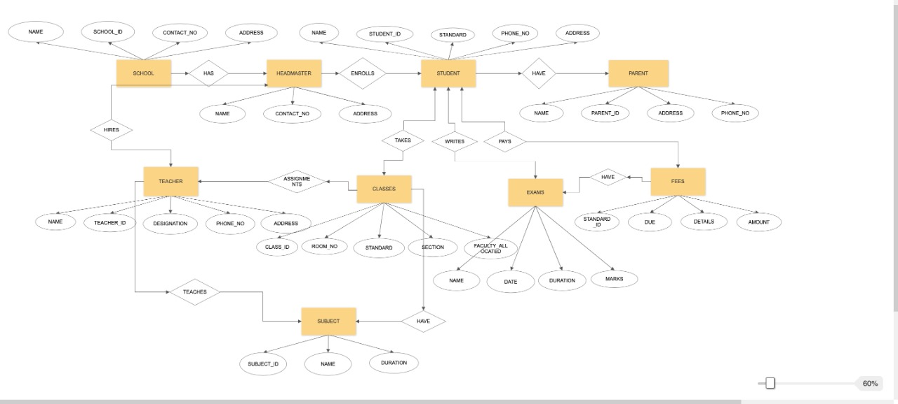

**Tables:**

* TABLE SCHOOL

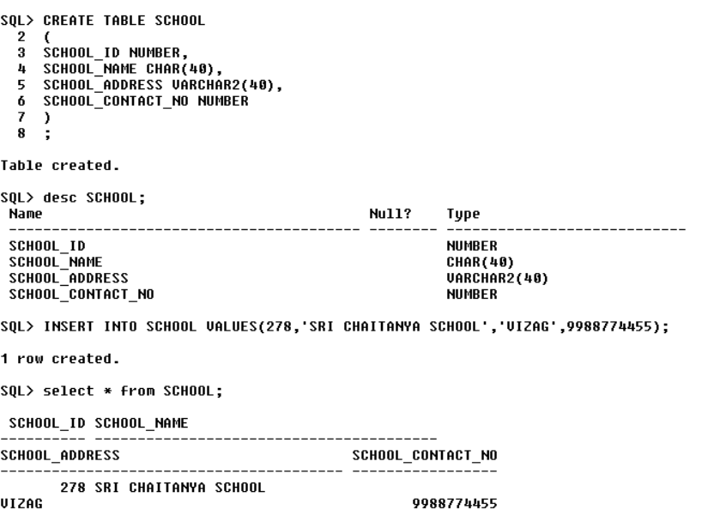

* TABLE HEADMASTER

* TABLE TEACHER

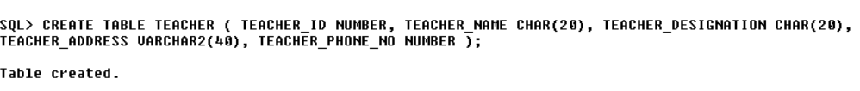

* TABLE STUDENT

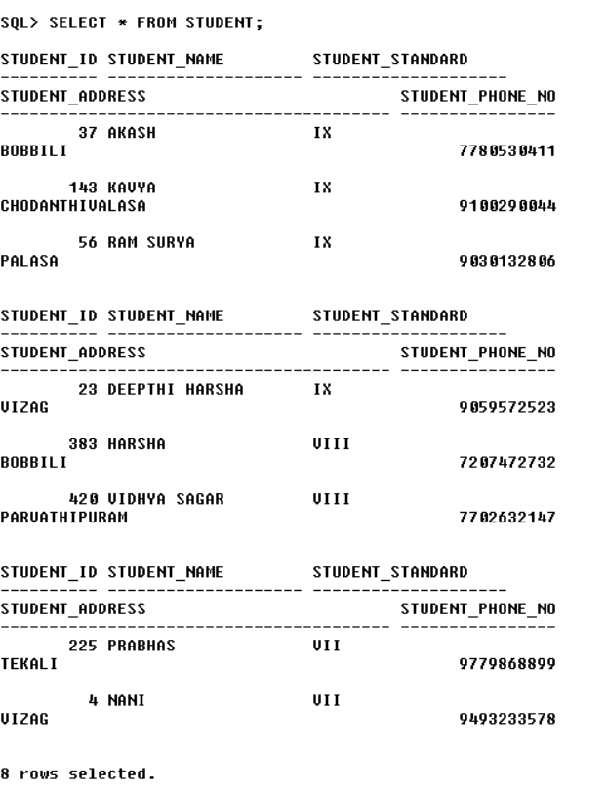

* TABLE PARENT

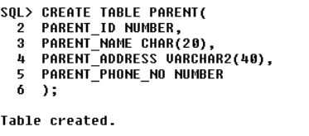

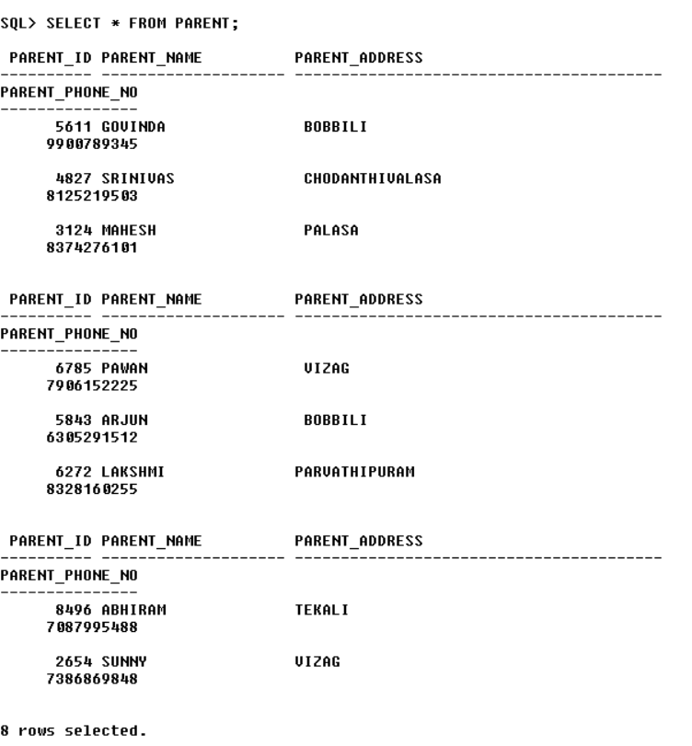

* TABLE CLASS

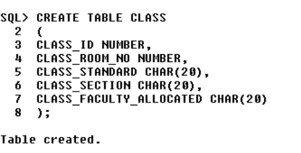

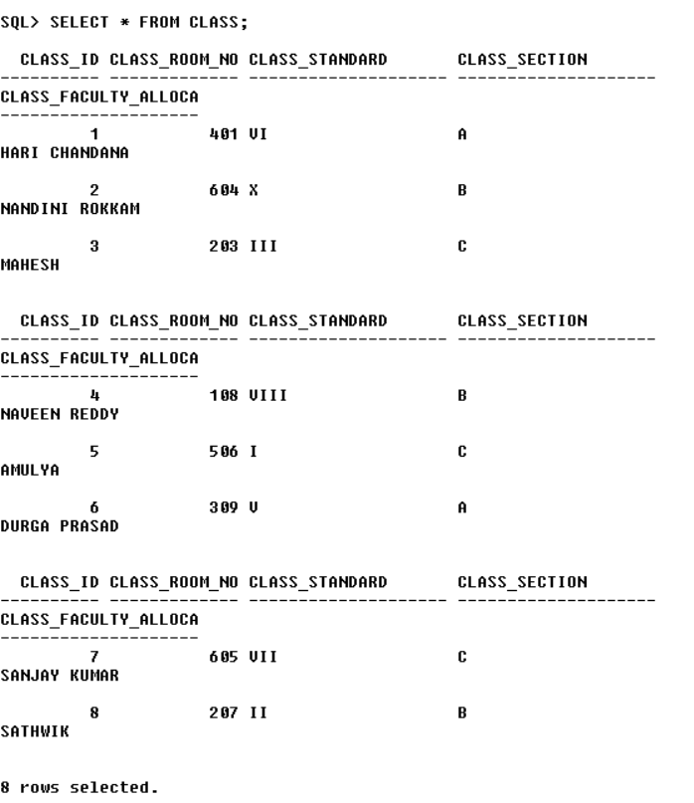

* TABLE SUBJECT

* TABLE EXAM

* TABLE FEE

**Keys Used:**

* Primary Key
* Alternate Key
* Unique Key
* Composite Key
* Foreign Key

**Codes:**

Code for School Table:

CREATE TABLE SCHOOL(

SCHOOL_ID NUMBER,

SCHOOL_NAME CHAR(40),

SCHOOL_ADDRESS VARCHAR2(40),

SCHOOL_CONTACT_NO NUMBER);

desc SCHOOL;

INSERT INTO SCHOOL VALUES(278,'SRI CHAITANYA SCHOOL','VIZAG',9988774455);

select * from SCHOOL;

Code for Headmaster Table:

CREATE TABLE HEADMASTER (

HEADMASTER_NAME CHAR(20),

HEADMASTER_ADDRESS VARCHAR2(40),

HEADMASTER_CONTACT_NO NUMBER );

INSERT INTO HEADMASTER VALUES('ADHI NARAYANA','VIZAG',8526475651);

SELECT * FROM HEADMASTER;

Code for Teacher Table:CREATE TABLE TEACHER(TEACHER_ID NUMBER,TEACHER_NAME CHAR(20),TEACHER_DESIGNATION CHAR(20),TEACHER_ADDRESS VARCHAR2(40),TEACHER_PHONE_NO NUMBER);

INSERT INTO TEACHER VALUES(111,'DURGA PRASAD','BIOLOGY','MADHILAPALEM',7893924278);

INSERT INTO TEACHER VALUES(112,'SANJAY KUMAR','PHYSICS','GAJUWAKA',9515306769);

INSERT INTO TEACHER VALUES(113,'HARI CHANDANA','CHEMISTRY','RK BEACH',9502317686);

INSERT INTO TEACHER VALUES(114,'NAVEEN REDDY','MATHEMATICS','MADHURAWADA',7995272848);

INSERT INTO TEACHER VALUES(115,'NANDINI ROKKAM','SOCIAL','MARIKAVALASA',7815850811);

INSERT INTO TEACHER VALUES(116,'MAHESH','ENGLISH','VIZIANAGARAM',9346574720);

INSERT INTO TEACHER VALUES(117,'SATHWIK','HINDI','SHIMHACHALAM',9494090138);

INSERT INTO TEACHER VALUES(118,'AMULYA','TELUGU','ARILOVA',9640691552);

SELECT * FROM TEACHER;

Code for Student Table:

CREATE TABLE STUDENT(

STUDENT_ID NUMBER,

STUDENT_NAME CHAR(20),

STUDENT_STANDARD CHAR(20),

STUDENT_ADDRESS VARCHAR2(40),

STUDENT_PHONE_NO NUMBER

);

INSERT INTO STUDENT VALUES(037,'AKASH','IX','BOBBILI',7780530411);

INSERT INTO STUDENT VALUES(143,'KAVYA','IX','CHODANTHIVALASA',9100290044);

INSERT INTO STUDENT VALUES(56,'RAM SURYA','IX','PALASA',9030132806);

INSERT INTO STUDENT VALUES(23,'DEEPTHI HARSHA','IX','VIZAG',9059572523);

INSERT INTO STUDENT VALUES(383,'HARSHA','VIII','BOBBILI',7207472732);

INSERT INTO STUDENT VALUES(420,'VIDHYA SAGAR','VIII','PARVATHIPURAM',7702632147);

INSERT INTO STUDENT VALUES(225,'PRABHAS','VII','TEKALI',9779868899);

INSERT INTO STUDENT VALUES(04,'NANI','VII','VIZAG',9493233578);

SELECT * FROM STUDENT;

Code for Parent Table:

CREATE TABLE PARENT(

PARENT_ID NUMBER,

PARENT_NAME CHAR(20),

PARENT_ADDRESS VARCHAR2(40),

PARENT_PHONE_NO NUMBER

);

INSERT INTO PARENT VALUES(5611,'GOVINDA',' BOBBILI',9900789345);

INSERT INTO PARENT VALUES(4827,'SRINIVAS',' CHODANTHIVALASA',8125219503);

INSERT INTO PARENT VALUES(3124,'MAHESH',' PALASA ',8374276101);

INSERT INTO PARENT VALUES(6785,'PAWAN',' VIZAG ',7906152225);

INSERT INTO PARENT VALUES(5843,'ARJUN',' BOBBILI',6305291512);

INSERT INTO PARENT VALUES(6272,'LAKSHMI', 'PARVATHIPURAM',8328160255);

INSERT INTO PARENT VALUES(8496,'ABHIRAM', 'TEKALI',7087995488);

INSERT INTO PARENT VALUES(2654,'SUNNY', 'VIZAG',7386869848);

SELECT * FROM PARENT;

Code for Class Table:

CREATE TABLE CLASS(

CLASS_ID NUMBER,

CLASS_ROOM_NO NUMBER,

CLASS_STANDARD CHAR(20),

CLASS_SECTION CHAR(20),

CLASS_FACULTY_ALLOCATED CHAR(20)

);

INSERT INTO CLASS VALUES(1,401,'VI','A','HARI CHANDANA');

INSERT INTO CLASS VALUES(2,604,'X','B','NANDINI ROKKAM');

INSERT INTO CLASS VALUES(3,203,'III','C','MAHESH');

INSERT INTO CLASS VALUES(4,108,'VIII','B','NAVEEN REDDY');

INSERT INTO CLASS VALUES(5,506,'I','C','AMULYA');

INSERT INTO CLASS VALUES(6,309,'V','A','DURGA PRASAD');

INSERT INTO CLASS VALUES(7,605,'VII','C','SANJAY KUMAR');

INSERT INTO CLASS VALUES(8,207,'II','B','SATHWIK');

SELECT * FROM CLASS;

Code for Subject Table:

CREATE TABLE SUBJECT(

SUBJECT_ID NUMBER,

SUBJECT_NAME CHAR(20),

SUBJECT_DURATION VARCHAR2(20)

);

INSERT INTO SUBJECT VALUES(1,'MATHEMATICS','45 MIN');

INSERT INTO SUBJECT VALUES(2,'PHYSICS','45 MIN');

INSERT INTO SUBJECT VALUES(3,'SOCIAL','45 MIN');

INSERT INTO SUBJECT VALUES(4,'TELUGU','45 MIN');

INSERT INTO SUBJECT VALUES(5,'CHEMISTRY','45 MIN');

INSERT INTO SUBJECT VALUES(6,'ENGLISH','45 MIN');

INSERT INTO SUBJECT VALUES(7,'BIOLOGY','45 MIN');

INSERT INTO SUBJECT VALUES(8,'HINDI','45 MIN');

SELECT * FROM SUBJECT;

Code for Exam Table:

CREATE TABLE EXAM(

EXAM_NAME CHAR(20),

EXAM_DATE DATE,

EXAM_DURATION VARCHAR2(20),

EXAM_MARKS NUMBER

);

INSERT INTO EXAM VALUES('TELUGU','16-APR-18','3 HOUR',80);

INSERT INTO EXAM VALUES('HINDI','17-APR-18','3 HOUR',80);

INSERT INTO EXAM VALUES('ENGLISH','18-APR-18','3 HOUR',80);

INSERT INTO EXAM VALUES('MATHEMATICS','19-APR-18','3 HOUR',80);

INSERT INTO EXAM VALUES('PHYSICS','20-APR-18','3 HOUR',80);

INSERT INTO EXAM VALUES('CHEMISTRY','21-APR-18','3 HOUR',80);

INSERT INTO EXAM VALUES('BIOLOGY','23-APR-18','3 HOUR',80);

INSERT INTO EXAM VALUES('SOCIAL','24-APR-18','3 HOUR',80);

SELECT * FROM EXAM;

Code for Fee Table:

CREATE TABLE FEE(

FEE_STUDENT_ID NUMBER,

FEE_AMOUNT NUMBER,

FEE_DUE NUMBER,

FEE_DETAILS CHAR(20));

INSERT INTO FEE VALUES(383,124000,0,'PAID');

INSERT INTO FEE VALUES(420,127000,5000,'FEE PENDING');

INSERT INTO FEE VALUES(225,116000,2500,'FEE PENDING');

INSERT INTO FEE VALUES(037,124000,0,'PAID');

INSERT INTO FEE VALUES(56,189000,0,'PAID');

INSERT INTO FEE VALUES(04,196000,4000,'FEE PENDING');

INSERT INTO FEE VALUES(23,188000,2000,'FEE PENDING');

INSERT INTO FEE VALUES(143,124000,0,'PAID');

SELECT * FROM FEE;

**DDL AND DML:**

STATEMENT-1:

select STUDENT_NAME || STUDENT_ID FROM STUDENT;

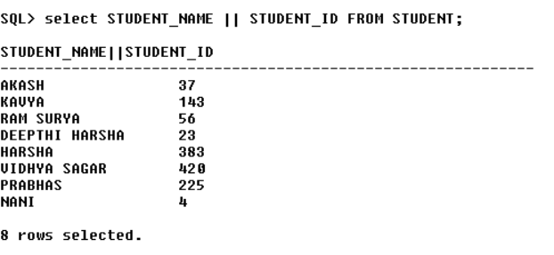

STATEMENT-2:

SELECT STUDENT_NAME || 'AND STUDENT_ID IS' || STUDENT_ID FROM STUDENT;

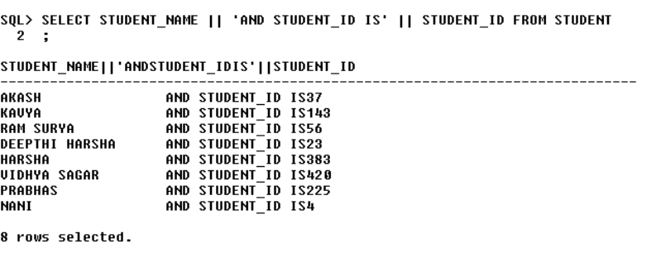

STATEMENT-3:

SELECT * FROM STUDENT WHERE STUDENT_NAME LIKE '%AK%';

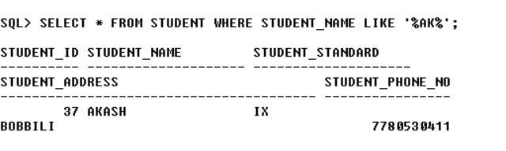

STATEMENT-4:

UPDATE STUDENT SET STUDENT_PHONE_NO=9398579684 WHERE STUDENT_ID=143;

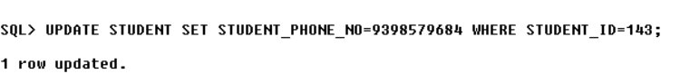

STATEMENT-5:

UPDATE STUDENT SET STUDENT_STANDARD='VII' WHERE STUDENT_NAME='HARSHA’;

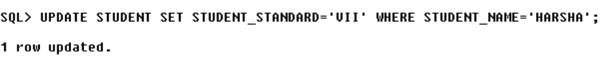

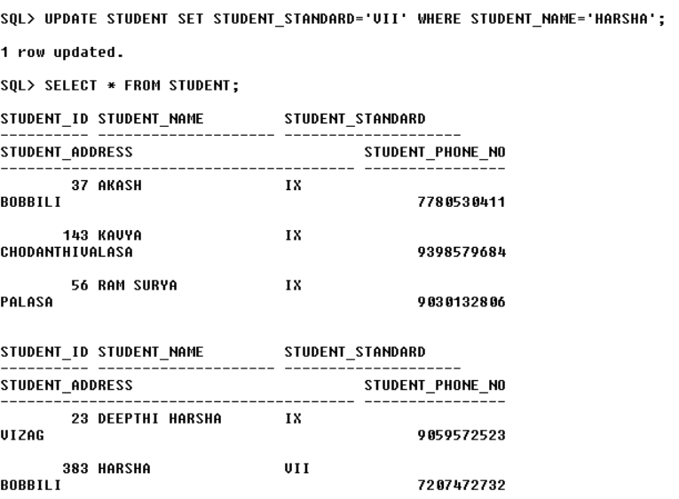

STATEMENT-6:

ALTER TABLE STUDENT ADD(GENDER CHAR);

STATEMENT-7:

ALTER TABLE STUDENT MODIFY(GENDER VARCHAR2(20));

Select * from STUDENT;

STATEMENT-8:

DELETE FROM STUDENT WHERE STUDENT_ID=4;

Select * from STUDENT;

STATEMENT-9:

CREATE TABLE NEW_STUDENT AS SELECT * FROM STUDENT;

DESC NEW_STUDENT;

SELECT * FROM NEW_STUDENT;

RENAME NEW_STUDENT TO STUDENTS;

SELECT * FROM STUDENTS;

STATEMENT-10:

DROP TABLE STUDENTS;

TRUNCATE TABLE STUDENT;

**PL/SQL COMMANDS**

1:

set serveroutput on

DECLARE

A NUMBER;

BEGIN

UPDATE FEE SET FEE_DUE=0 WHERE FEE_STUDENT_ID=225;

IF SQL%FOUND THEN

dbms_output.put_line('DUE IS UPDATED');

END IF;

IF SQL%NOTFOUND THEN

dbms_output.put_line('DUE IS NOT UPDATED');

END IF;

A:=SQL%ROWCOUNT;

dbms_output.put_line(A);

END;

/

select * from FEE;

2:

DECLARE

A NUMBER;

BEGIN

UPDATE FEE SET FEE_DUE=0,FEE_DETAILS='PAID' WHERE FEE_STUDENT_ID=225;

IF SQL%FOUND THEN

DBMS_OUTPUT.PUT_LINE('DUE IS UPDATED');

END IF;

IF SQL%NOTFOUND THEN

DBMS_OUTPUT.PUT_LINE('DUE IS NOT UPDATED');

END IF;

A:=SQL%ROWCOUNT;

DBMS_OUTPUT.PUT_LINE(A);

END;

/

select * from FEE;

3:

DECLARECURSOR F5 IS SELECT * FROM FEE WHERE FEE_STUDENT_ID=420;A FEE%ROWTYPE;BEGINOPEN F5;LOOPFETCH F5 INTO A;EXIT WHEN F5%NOTFOUND;dbms_output.put_line(A.FEE_DUE);UPDATE FEE SET FEE_DUE=FEE_DUE+2000;END LOOP;CLOSE F5;END;

/

SELECT * FROM FEE;

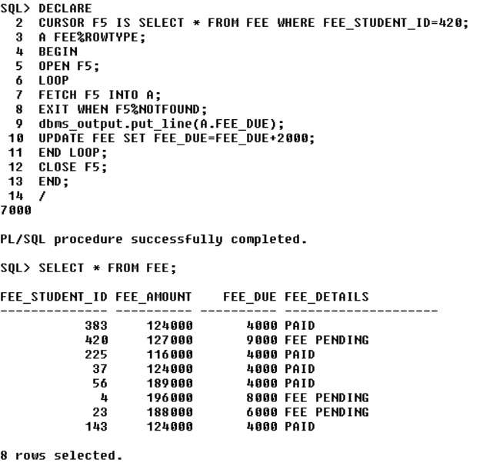

4:

DECLARE

A NUMBER;

BEGIN

UPDATE CLASS SET CLASS_FACULTY_ALLOCATED='APARNA' WHERE CLASS_ID=5;

IF SQL%FOUND THEN

dbms_output.put_line ('FACULTY IS ALLOCATED');

END IF;

IF SQL%NOTFOUND THEN

dbms_output.put_line ('FACULTY IS NOT ALLOCATED');

END IF;

A:=SQL%ROWCOUNT;

dbms_output.put_line (A);

END;

SELECT * FROM CLASS;

**----THE END----**